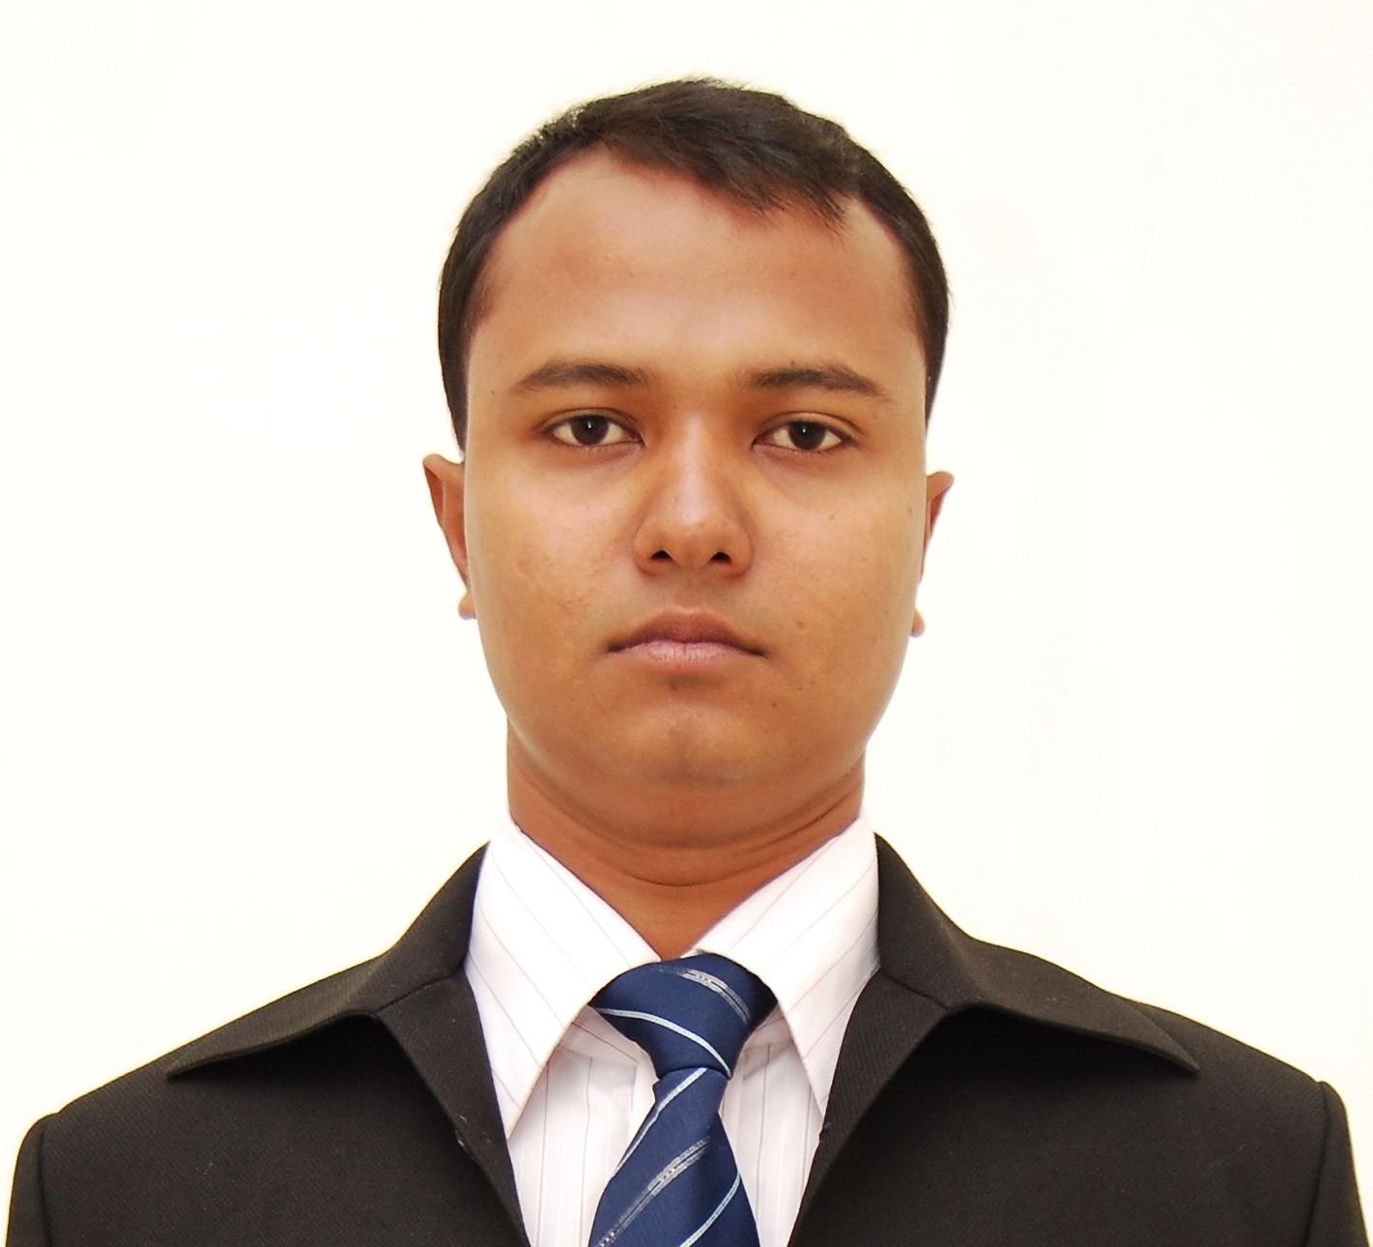
Md. Mohiuddin Siddique
- 132, Rail Road (Asrom More) Near Honda Showroom, Jessore
- mohinbubt@gmail.com • Mobile (Off): 01972-328310 Mobile (Res.) 01913-852828

OBJECTIVE To serve an organization by utilizing my acquired education, experience, creativity and commitment, that will provide dynamic working environment and opportunity for steady career growth & also like to be part of a team which is vibrant, diverse & most of all creative

EDUCATION M.B.A. (Major in Marketing), Bangladesh University of Business & Technology (BUBT), 2011 (Appeared)

B.B.A. (Major in Marketing), Bangladesh University of Business & Technology (BUBT), 2010

HSC (Business Studies), Mirpur University College, 2006

SSC (Business Studies), Mirpur Bangla High School, 2004

Career Summary Responsible about Department of Commercial & Distribution, warehouse management and Supply chain Work for logistic support.

Special Qualification
- Proficient in advance excel and PowerPoint
- Well knowledge of SAP production server
- Working knowledge of Photoshop

EXPERIENCE Commercial In charge, CEAT AKKHAN LIMITED, Jessore Regional Office,
Responsibility: Sales Accounting & Distribution,
Job Duration: (From November 2013 to October 2014 look after Bogra Regional Office, December 2014 to June 2015 look after Dhaka Regional Office and June 2015 to June 2017 look after Sylhet Regional Office) July 2017 to present.
Man Power: Looking after a team of 5 employees.
Horizon of operation: Khulna and Barishal division.

Job Descriptions:
- Supervision of Regional Office and Warehouses.
- Ensure accuracy, cost control, efficiency, safety & Security of Warehouses.
- Responsible for HR related issues of RO Staffs, Regular meeting and counseling of staffs for motivating.
- Warehouse maintenance like goods in/out, monitoring stock levels,
- Plan and prepare date-wise distribution programs with ensure FEFO
- Maintain Stock reconciliations with Daily Stock Reconciliation/ Monthly Stock Reconciliation reports as per laid down procedures.
- To facilitate SCM related issues (Forecasting)
- Preparing the voucher of petty cash balance
- Maintaining day to day operating cost of the Regional Office
- Cash in hand statement preparing on daily basis
- Monthly budget preparing
- RO banking & reconciliation,
- Customer accounts related problem solving
- Statement preparing
- Raising invoice
- Compliance statutory
- Monitoring all Register book like attendance, visitor log book, generator, warehouse open & close, employee movement etc.
- All types of admin related issues, like employee’s advance settlement.
- Promotional account maintenance, like trade/consumer promotion.
- All types of RO VAT related issue, like VAT return, Current register, Musak challan, price declares, Maintain purchase & sales register etc.
- Customer claim inspection, analysis & settlement.

Accounts & Distribution Officer, Berger Paints Bangladesh Limited, Sylhet Sales Office (From December 2011to October 2013). Looked after a team 13 employees
Horizon of operation: Sylhet Depot
- Maintaining day to day operating cost of the Depot
- Customer accounts related problem solving
- Raising invoice
- Depot banking,
- Depot account maintenance
- Preparing the voucher of petty cash balance
- Promotional account maintenance, like Scratch Card Cash, Samparka Scheme Cash & so on.
- To facilitate SCM related issues
- Reconciliation
- Product dispatching
- Inventory maintenance

Accounts & Distribution Officer (Under 3rd Party Enrollment), Berger Paints Bangladesh Limited, Barisal Sales Office (August 2011-December 2011)
Territory: Greater Barisal

SALEAS SUPPORT OFFICER (Under 3rd Party Enrollment), Berger Paints Bangladesh Limited, Dhaka Sales Office (March 2011-July 2011)

ACHIEVEMENT
- Trained 6 new employee
- Commercial operation starting to new Regional Offices of CEAT at Bogra
- Built a new team to commercial work for the company
SKILLS
- Strong communication skills
- Ability to work in a team
- Excellent ability to adapt to difficult situation
- Well knowledge of SAP production server
- Time & project management
- Proficient in advance excel and PowerPoint
- Working knowledge of Photoshop,
- Leadership skill

AREA OF
STREANGHT
- Capability of quick learning
- Think assigned job is my own
- Positive in learning and to teach
- Stress tolerance ability
- Creating positive work environment

TRAINING Claim Settlement Process in SAP, Head Office Board Room. CEAT AKKHAN LTD. 20 November, 2015
CLAIM AUTHORIZATION, Bogra Regional Office, CEAT AKKHAN LTD. 17 March - 20 March, 2014
TOTAL QUALITY MANAGEMENT (TQM), Corporate Office, CEAT AKKHAN LTD. 2 November, 2013
Exercise and Maintenance of Depot Accounts & Distribution, Dhaka Sales Office, Berger Paints Bangladesh Ltd. August-December, 2011
How to Maintain a Depot Accounts, Corporate Office, Berger Paints Bangladesh Ltd. 27 May-28 May 2012
SUPPLY CHAIN MANAGEMENT, Sylhet Sales Office, Berger Paints Bangladesh Ltd. 14 Apri-16 April, 2012
Budget Upload System in SAP, Dhaka Sales Office, Berger Paints Bangladesh Ltd. 14 July, 2012
Training on fire safety & first aid management, Bdjobs Training Center, BdJobs. 19 October-20 October, 2012

PERSONAL Father’s Name : Late Md. Abdul Khaleque
Information Mother’s Name : Mrs. Anowara Begum
Present Address : 132, rail road, (asrom more) near Honda showroom, Jessore.
Permanent Address : House#137/138, Road#03, Section#07, Pallabi Mirpur Dhaka-1216
Nationality : Bangladeshi
Religion : Islam (Sunni)
Marital Status : Married
Date of Birth : 10th December, 1989
Hobbies : Reading, meeting new people and traveling,
Watch Television.

Personal Ability to assimilate new ideas, concepts, methods and technologies comprehensively. Dedicated, innovative and self-motivated team player with a superior work ethic

REFERENCES Will be furnished upon request

Md. Mohiuddin Siddique

